Project 6

How to create a repository in GitHub

GitHub account:

1. Go to your profile created in GitHub and click on repositories.
2. Click on create repository and give name as abc or any other name.
3. Give description as Git Repository and repository as public.
4. In Quick setup, click on new repository and copy the codes.

Connect to instance:

Steps:

1. Create instance and click on connect and go to SSH client and copy the example SSH url.

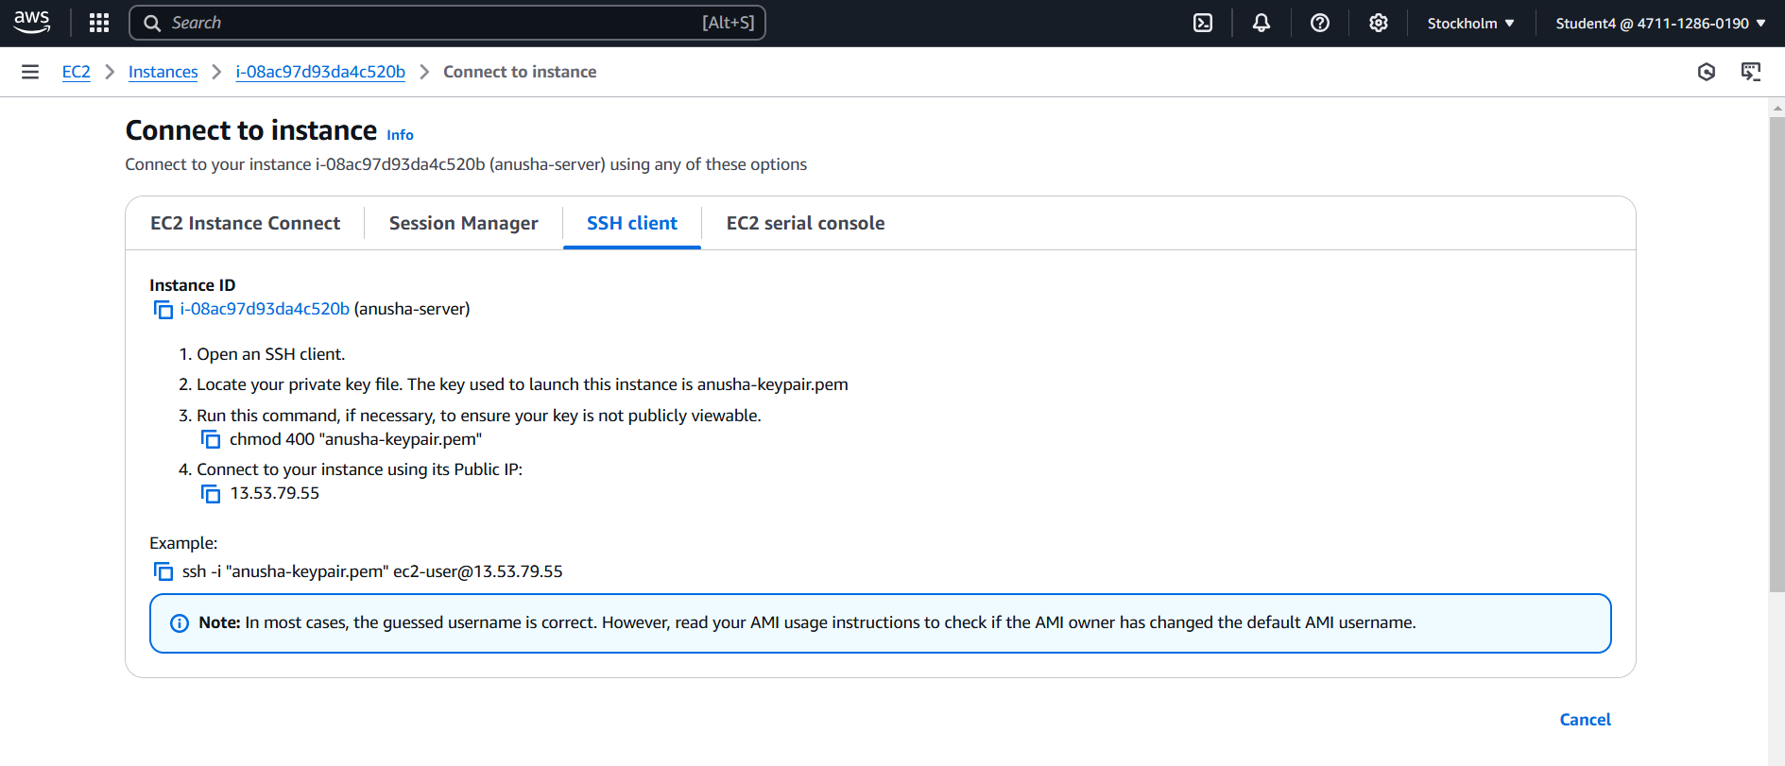

Command prompt:

Steps: follows as below screenshots

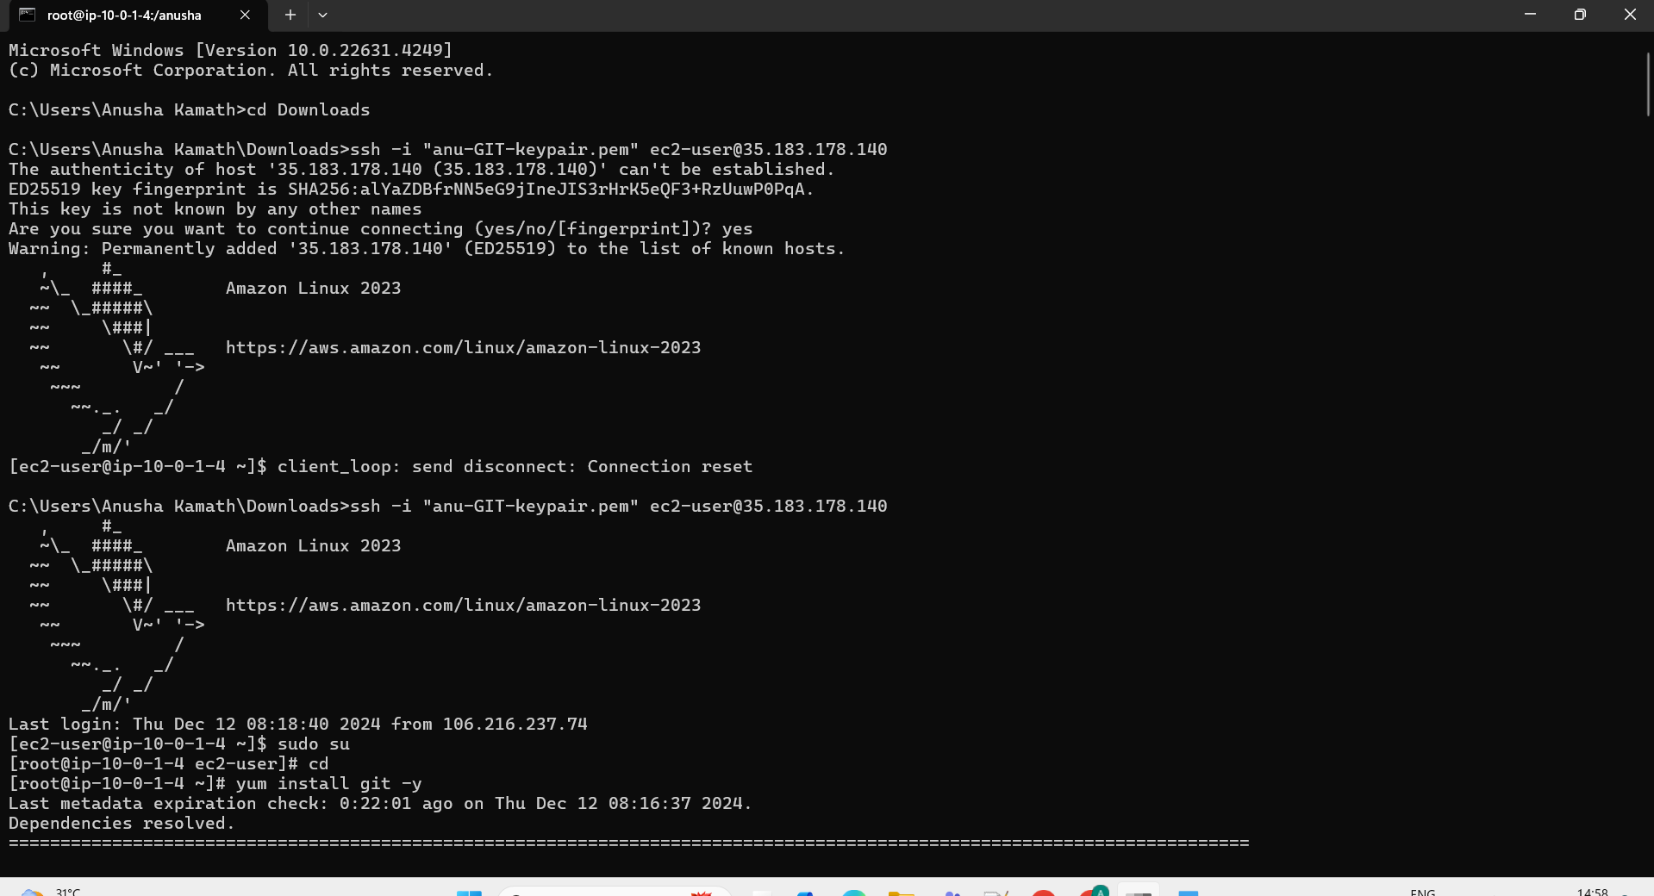

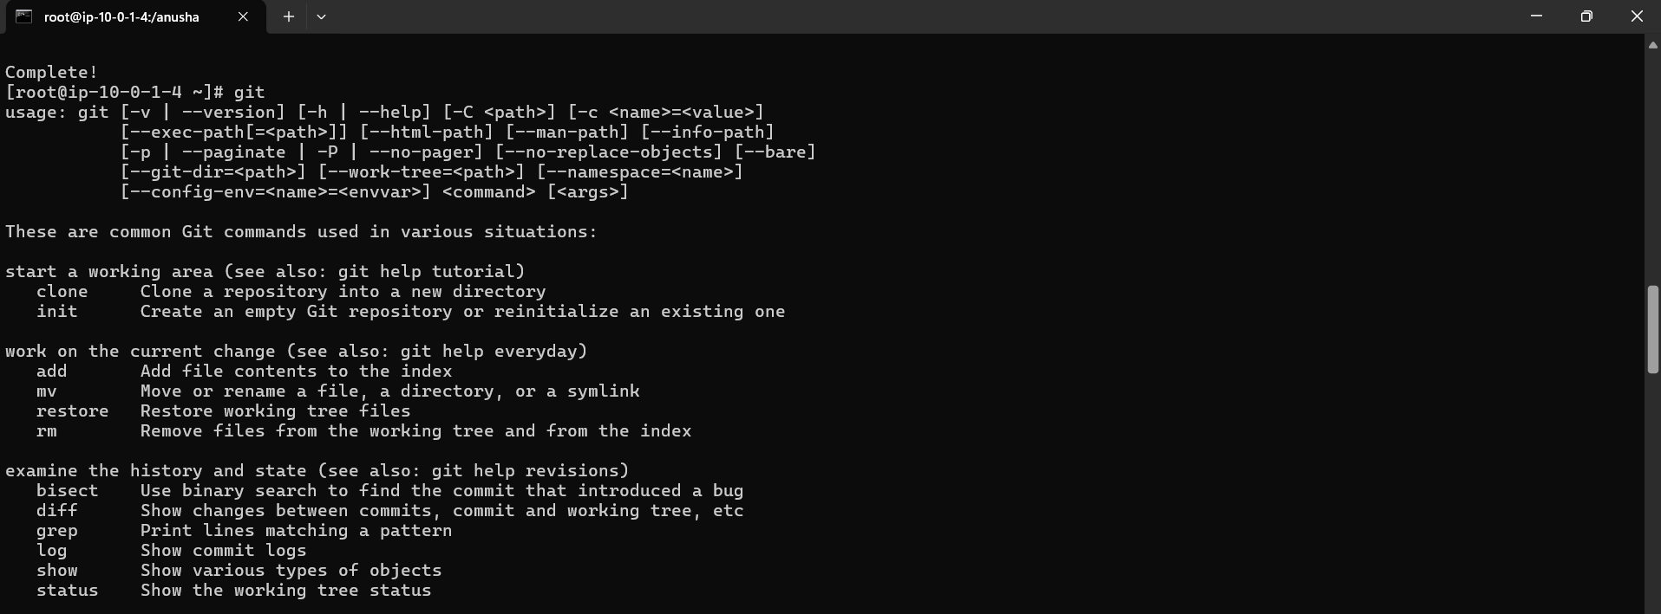

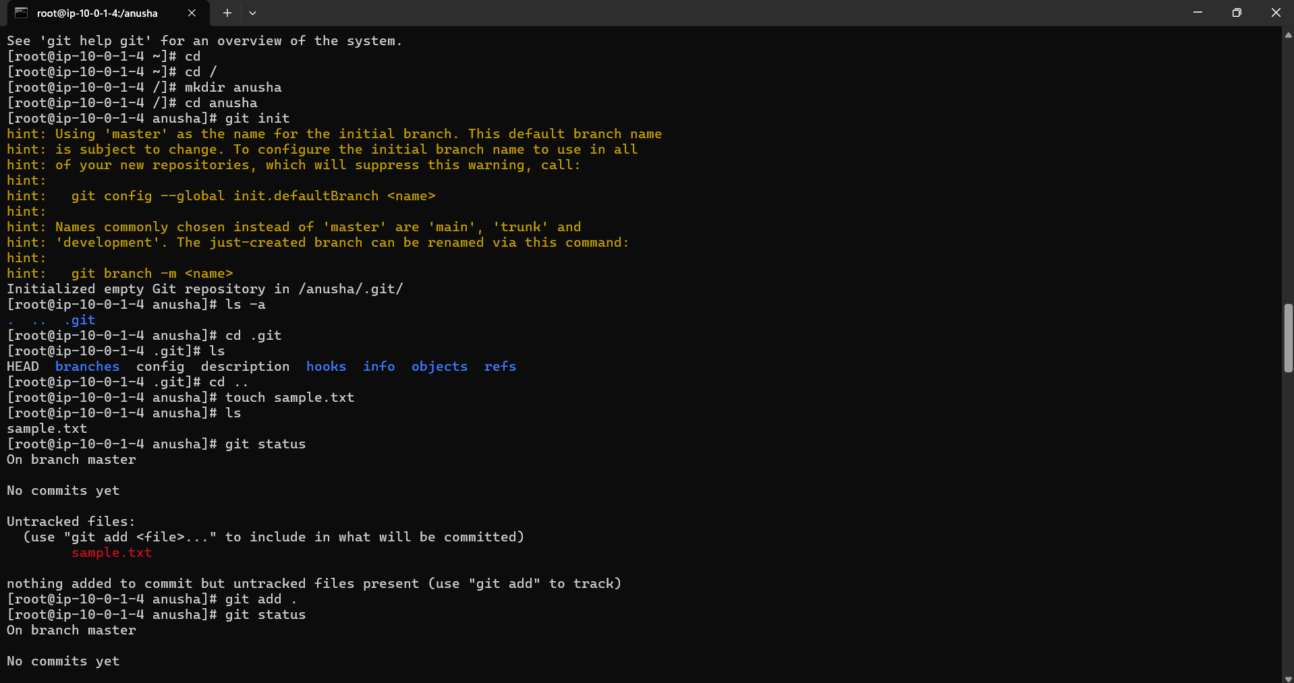

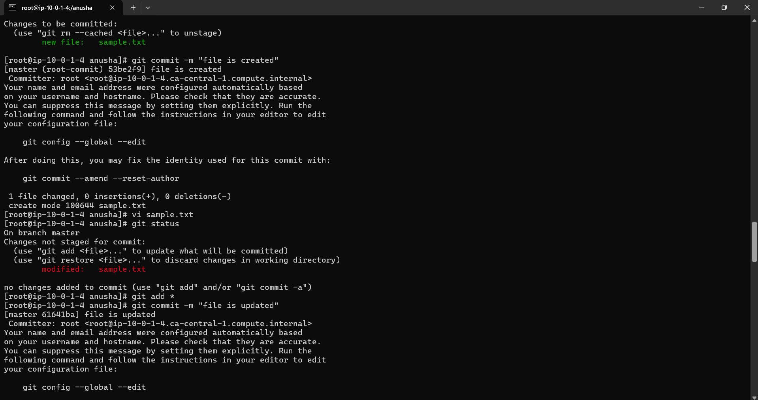

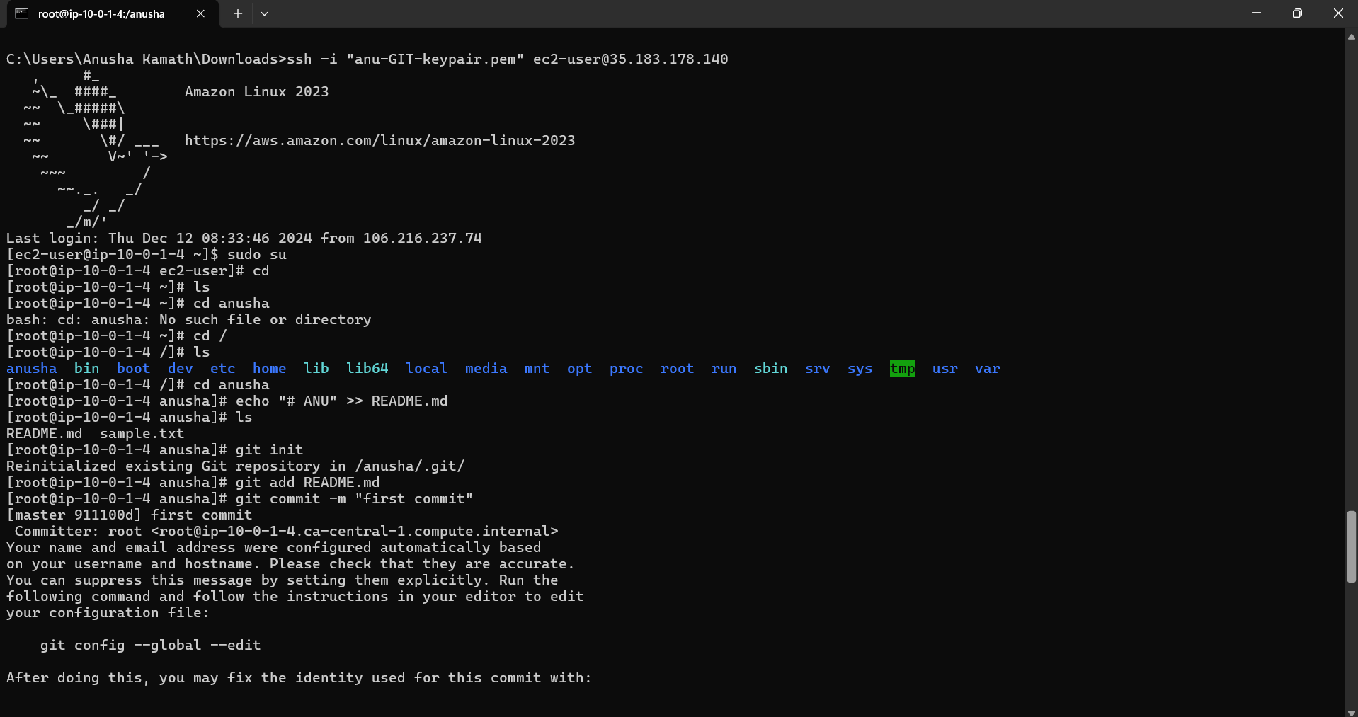

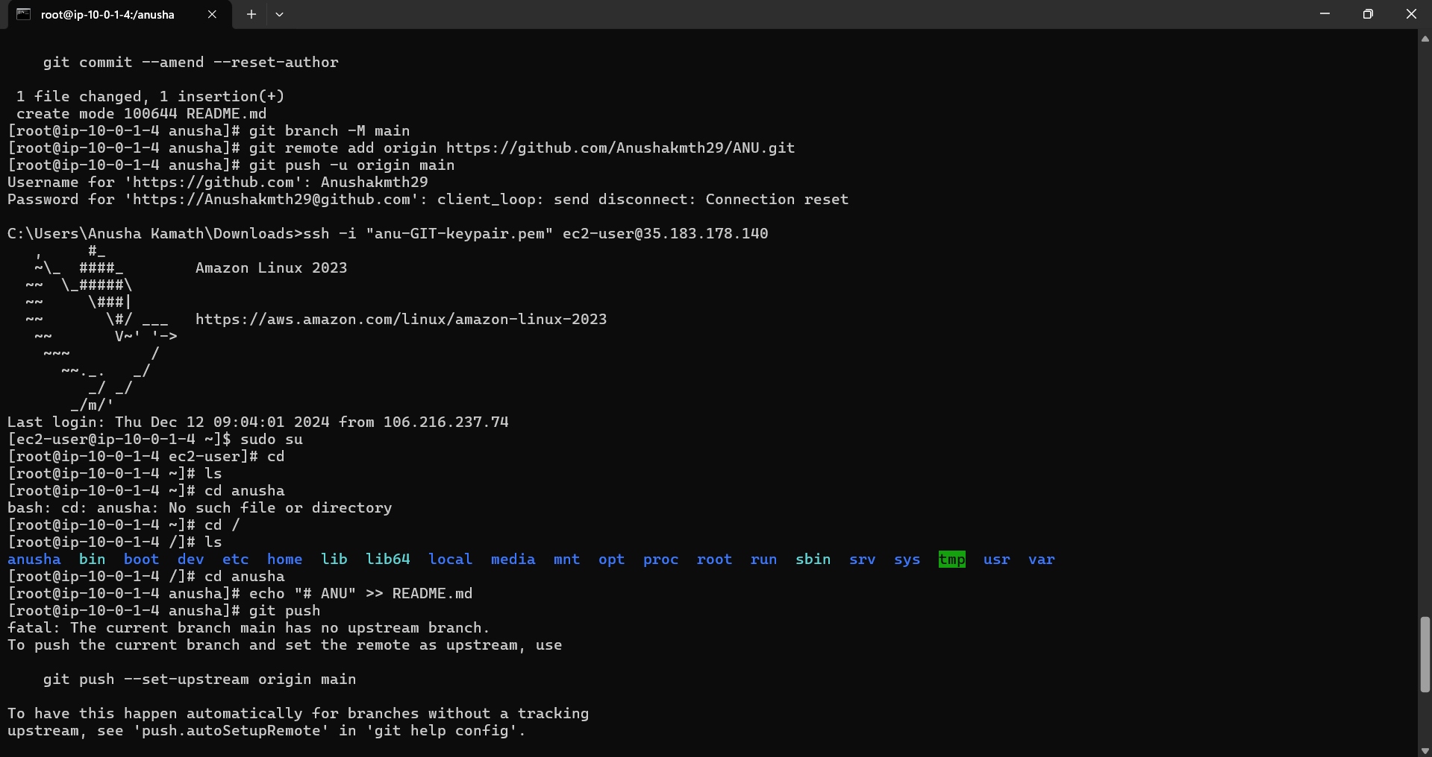

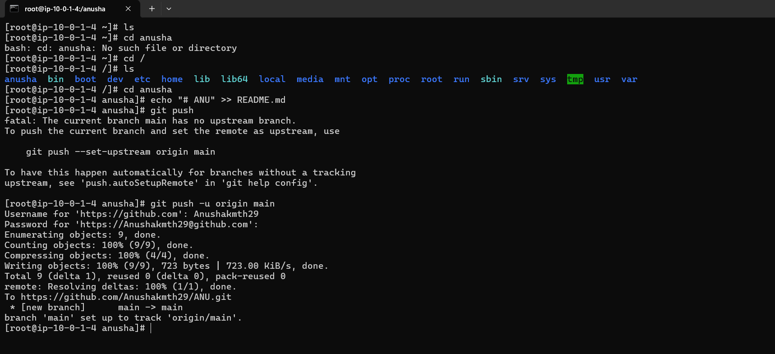

Final result: repository has been created.

